
MINISTRY FOR EDUCATION AND SCIENCE OF RUSSIA
________________________________

SAINT PETERSBURG ELECTROTECHNICAL UNIVERSITY

«LETI»
________________________________

APPROVED

__________________________
Date, signature

Application for Delivery E-bill

PROJECT MANAGEMENT PLAN

PMP_T04_00.12

Electronic & Paper

15 pages

St. Petersburg / Санкт-Петербург
2021
HISTORY

Version #/ Версия № | Author / Кто разработал | Data / Дата | Short description / Причина
00.10 | Naveen/Навин,  Chubchik  Alexander  Olegovich,  Ryleev  Vladislav  Valerevich | 03.03.21 | The first version
00.20 | Naveen/Навин,  Chubchik  Alexander  Olegovich,  Ryleev  Vladislav  Valerevich | 18.03.21 | Detail requirements
00.30 | Naveen/Навин,  Chubchik  Alexander  Olegovich,  Ryleev  Vladislav  Valerevich | 22.04.21 | Architecture, prepared for review
01.00 | Naveen/Навин,  Chubchik  Alexander  Olegovich,  Ryleev  Vladislav  Valerevich | 29.05.21 | Final version, gant diagram and risks updated

Project team / Список исполнителей

№ | Name / ФИО | Group / Группа | Project role / Обязанности | Contact Information / Контактные данные (email/телефон)
1 | Naveen/навин | 6300 | Programmer, Lead ,Quality Manager ,CM | Naveensheoran1000@gmail.com
2 | Chubchik Alexander  Olegovich | 6300 | Tester, Database ,CM | very_vazhno@mail.ru
3 | Ryleev  Vladislav  Valerevich | 6300 | Programmer ,Tester ,CM | armenignat@gmail.com
Teacher / Преподаватель
Filippov Evgeny Vasilyevich / Филиппов Евгений Васильевич e.philippov.leti@mail.ru
Aleksandr Eroshkin /Александр Ерошкин
a.eroshkin@sigma-it.ru

index
1. BASIS FOR DEVELOPMENT 05
2. DEVELOPMENT GOALS 05
3. Detail requirements 05
4. HIGH-LEVEL DESIGN 08
5. work breakdown structure and efforts estimation 10
6. Key milstones 12
7. Chosen technology and development framework 12
8. configuration and change management 13
9. project specific process 13
10. project risks 14
11. project schedule 14
12. Test plan 14
appendix 1. test cases 14
appendix 2. test results
appendix 3. defects 15

BASIS FOR DEVELOPMENT
Development is carried out on the basis of the requirements for the course work in the discipline "Software Engineering" .
Full name of the project :----
“Application for Delivery E-bill”

Short name of the program (nick-name, 4-5 characters) _____ E-bill

DEVELOPMENT GOALS
The software product is intended to development of android application for the Delivery E-bill. Using this application Delivery boys will not need any bill slip on paper .So we can save our tree as we know papers are prepared with trees.

Detail requirements
System Requirement -
Installation on Windows Machine
Requirements:
- 4 GB RAM minimum, 8 GB RAM recommended
- 2 GB of available disk space minimum, 4 GB Recommended (500 MB for IDE + 1.5 GB for Android SDK and emulator system image)
- 1280 x 800 minimum screen resolution
- Microsoft Windows 7/8/10 (32- or 64-bit). The Android Emulator supports 64-bit Windows only

Use Case
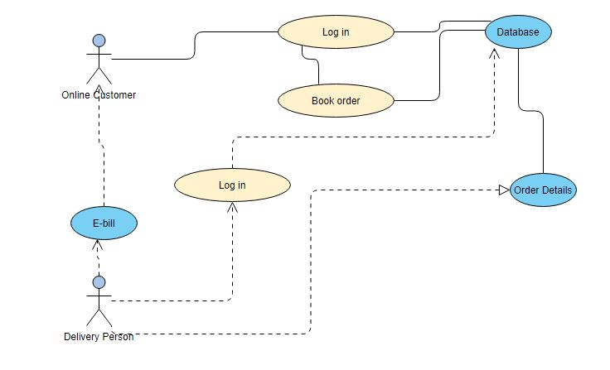

Register Delivery Boy:
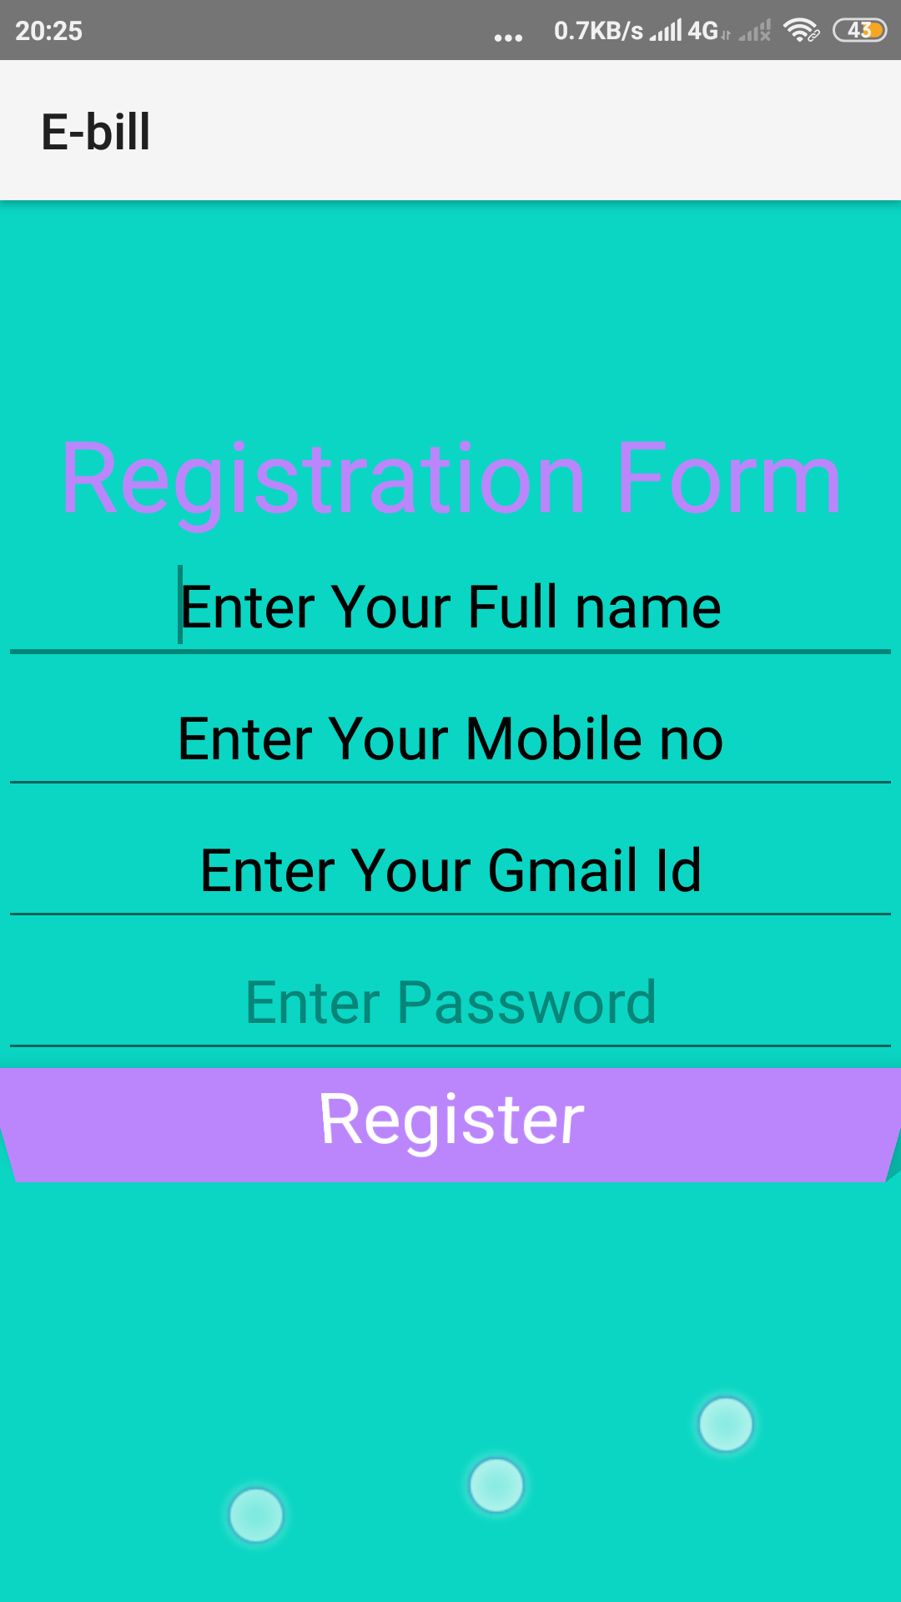Log in
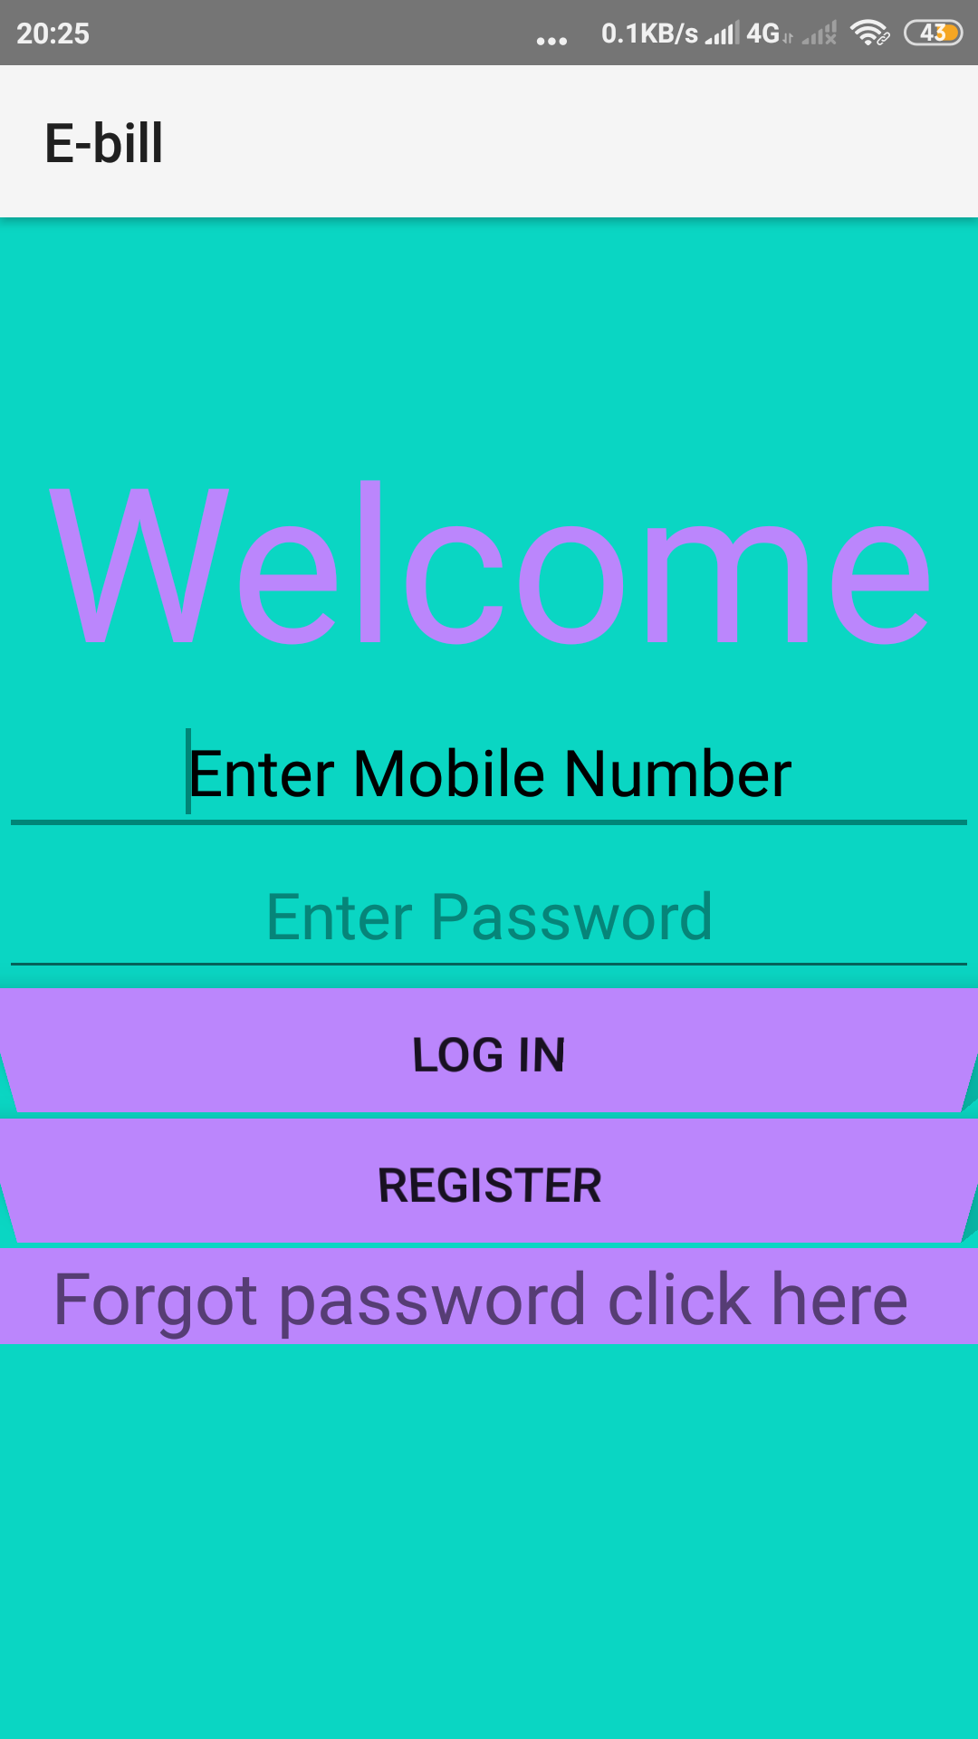

high level design
MVP
Model: the data layer
View: the UI layer, displays data received from Presenter, reacts to user input. On Android, we treat Activities, Fragments, and android.view.View as View from MVP.
Presenter: responds to actions performed on the UI layer, performs tasks on Model objects (using Use Cases), passes results of those tasks to Views
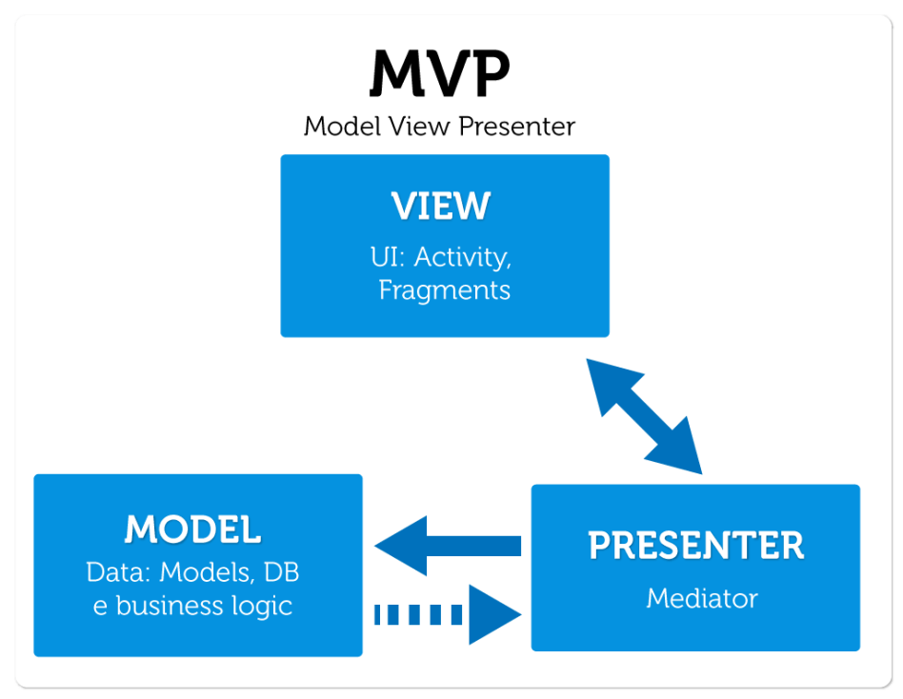

Basic Design

Delivery Boy
Customer
Request

Database

work breakdown structure and efforts estimation

Now:-

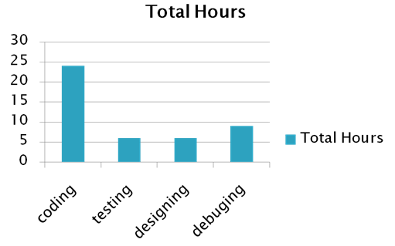

FInal:-

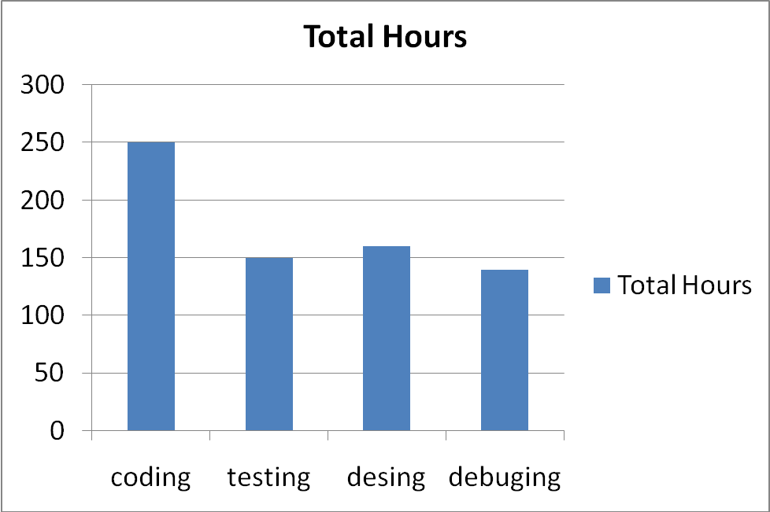

Key milstones
Table 1. Key milstones
№ | Start date / | End date | Description
1 | 05.02.21 | 03.03.21 | SOW developed, reviewed and signed
2 | 03.03.21 | 18.03.21 | Project Management Plan(PMP)
3 | 18.03.21 | 22.04.21 | Project Implementation – Phase 1
 | 31.03.21 | 14.04.21 | Authentication ,Registration
 | 14.04.21 | 22.04.21 | Real time Database
4 | 22.04.21 | 26.05.21 | Project Implementation – Phase 2
 | 23.04.21 | 07.05.21 | Forgot password ,new Design
 | 07.05.21 | 26.05.21 | Getting bill format , Delivery confirmation
5 | 26.05.21 | 02.06.21 | Course project completed, presentation and final report prepared for defense

Chosen technology and development framework

- Android Studio
- Android Software Development Kit (SDK)
- XML
- JAVA
- Firebase

configuration and change management

Version control system:-
For our project we used Github to store the code and other documents.

Branch policy:-
We have three branches for our project.
1 For Coding
2 Testing
3 Debugging
Document Naming:
T04_E-bill_DOC-Type.extension
where,
DOC-Type document abbreviation:
◦ SOW - Statement of Work
◦ PMP - Project Management Plan
◦ WBS - Work Break-down Structure
◦ CMP - Configuration Management Plan
◦ PKM - Protocol of Kick-off Meeting
◦ WR -Weekly Report
◦ METRICS - Project Metrics
◦ TESTS - Test Cases
◦ DEFECTS - Defects
◦ TR - Test Report

project specific process
Development model:-
We will use the following development model “Agile model”.
Using this Model we create 5 sprints .
2 sprints for the Phase 1 implementation of the project (Check point 2)
2 sprints for the Phase 2 implementation of the project (Check point 3) .
1 sprint for the final check point 4.

Reporting rules:-
Weekly report by the project team.
Be punctual all team member.
Strictly follow deadline.

project risks

Our team created a risk register with following details:-
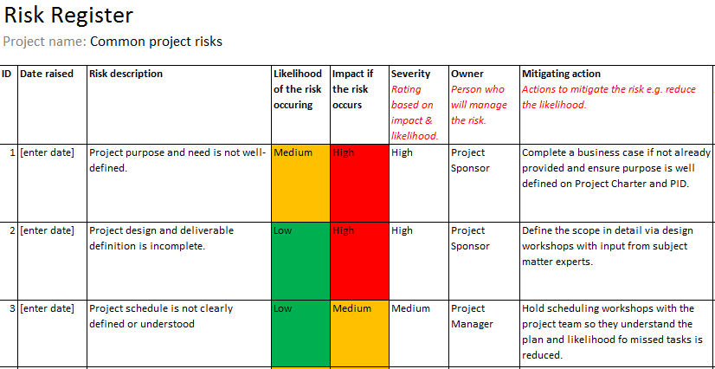

project schedule

REFERENCE :sow_t04_2021

Test plan
Appendix 1
  - Functional testing (3 test cases for every interaction point)
  - Stress testing using Firebase test lab (8 cases)
  - Usability testing (7 test cases)

Appendix 2
Defects :
Week no. | Description | Status*
1 | 5 bugs | 5 closed
2 | 5 bugs | 5 closed
3 | 7 bugs | 7 closed
4 | 9 bugs | 9 closed
5 | 2 bugs | 2 closed
6 | 3 bugs | 2 closed
* ( open ,closed)

Defects statistic on categories :
Defect Categories | Number  Total / open
Critical | 7 / 7
Major | 7 / 7
Regular | 4 / 4
Minor | 5 / 5
Enhancement | 8 / 8

Appendix 3:
Defects statistics on state :
Defects State | Number of bugs
Open | 31
Closed | 30

